Exercise 1:
Implementing the Singleton Pattern

class Singleton {
private static Singleton obj = new Singleton();
private Singleton() {
System.out.println("Singleton Object Created");
}
public static Singleton getInstance() {
return obj;
}
public void display() {
System.out.println("Welcome to Singleton Pattern");
}
}
public class Main {

public static void main(String[] args) {

Singleton s1 = Singleton.getInstance();
Singleton s2 = Singleton.getInstance();

s1.display();
s2.display();

System.out.println(s1);
System.out.println(s2);

if (s1 == s2)
System.out.println("Both references point to the same object.");
else
System.out.println("Different objects created.");
}
}
OUTPUT:
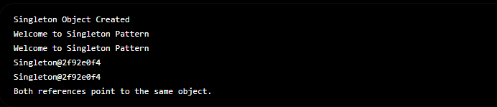
EXERCISE 2: Implementing the Factory Method Pattern
// Exercise 2: Implementing the Factory Method Pattern
interface Document {
void open();
}
// Concrete Product - Word Document
class WordDocument implements Document {
@Override
public void open() {
System.out.println("Opening a Word document.");
}
}
// Concrete Product - PDF Document
class PdfDocument implements Document {
@Override
public void open() {
System.out.println("Opening a PDF document.");
}
}
// Concrete Product - Excel Document
class ExcelDocument implements Document {
@Override
public void open() {
System.out.println("Opening an Excel document.");
}
}
// Abstract Factory
abstract class DocumentFactory {
public abstract Document createDocument();
}
// Concrete Factory - Word
class WordFactory extends DocumentFactory {
@Override
public Document createDocument() {
return new WordDocument();
}
}
// Concrete Factory - PDF
class PdfFactory extends DocumentFactory {
@Override
public Document createDocument() {
return new PdfDocument();
}
}
// Concrete Factory - Excel
class ExcelFactory extends DocumentFactory {
@Override
public Document createDocument() {
return new ExcelDocument();
}
}

// Main Class
public class Main {
public static void main(String[] args) {

// Create Word Document
DocumentFactory wordFactory = new WordFactory();
Document wordDoc = wordFactory.createDocument();
wordDoc.open();

// Create PDF Document
DocumentFactory pdfFactory = new PdfFactory();
Document pdfDoc = pdfFactory.createDocument();
pdfDoc.open();

// Create Excel Document
DocumentFactory excelFactory = new ExcelFactory();
Document excelDoc = excelFactory.createDocument();
excelDoc.open();
}
}


